The Lakes South Morang P-9 School
Literacy Data and Assessment
Reading

The Lakes South Morang P-9 School Vision for Data Use
At The Lakes South Morang P9 School assessment is used to provide an ongoing, ‘real time’ picture of each individual student and cohort. The tracking and monitoring of student outcomes is vital to informing purposeful teaching and allowing for student progress and scaffolded learning. Teaching staff at The Lakes South Morang P -9 School collect ongoing data in a variety of forms; these include pre and post-tests, rubrics, student performance and presentation. Mid and end of year Victorian Curriculum data is tracked and student groupings, topics and tasks are often realigned based on this information. Students are able to set goals and reflect on their outcomes and at times, renegotiate their own learning goals and targets to achieve success. We use the Assessment Pyramid (Fig 1.) to give staff an instant and clear picture of student progress and achievement in order to support ‘the next step’.

Formative Assessment Tools:
- English Online Interview – Foundation
- Running Records once per term – Years Foundation to 6 (Years 7 to 9 as indicated by student achievement at end of Year 6)
- Student Conferencing Folder (CAFÉ) – Years Foundation to 6
- PAT- R – Years 1 to 9 (Term 2)

Benchmark Assessments
- PM Benchmarking Terms 2 and 4 – Years Foundation to 6
- F&P Benchmarking Terms 1 and 3 – Years Foundation to 6
- On Demand Adaptive Test Terms 2 and 4 – Years 3 to 9
- PAT- R – Term 4 - Years 1 to 9

CAT (Common Assessment Task): Unit Reading Assessments
Fig 1.
NAPLAN

Explanation of how the Assessment Pyramid is used at The Lakes.
Formative assessment
At this level of the pyramid teachers at The Lakes under take the following:
Reading
Teachers at The Lakes South Morang P9 School use formative assessment data to inform their teaching on a continuous basis. Literacy sessions on reading, writing, vocabulary and speaking and listening have clear goals established based on unit outlines. Teachers have collaboratively developed authentic literacy work that is challenging and engaging and provides evidence of students’ progress towards the unit’s goals. The work the students do throughout the unit provides the evidence for ongoing formative assessment. Students have individual goals and are shown ways to demonstrate progress as they work towards achieving these goals.

Teachers build a repertoire of assessment tools and strategies to collect data and evidence around:
- Motivation and engagement in reading
- Decoding
- Fluency
- Comprehension
- Speaking and listening around reading
The PAT-R (Comprehension) Test is administered twice a year, at the beginning of Semester 1 and 2 from Years 1 to 9. Data is analysed by teachers and used for instructional purposes. At the whole school level the data is used to monitor student growth across a school year and from year to year. It also supports the identification of students who need intervention. Administration Protocols ensure consistent administration across the school (See appendix 3)
The English Online Interview (EOI) is used at The Lakes South Morang P9 School to assess the English skills of all students in Foundation. It is aligned to English in the Victorian Curriculum F-10. The EOI reports achievement in the language modes of Reading, Writing and Speaking and Listening. The assessment is administered within the mandated assessment periods set down by the Department of Education.

Running records are used at The Lakes South Morang P9 School to provide an insight into a student’s reading as it is happening (Clay, 1993).
A Running Record provides information on the following:
- a score of word reading accuracy
- an analysis of a reader's errors and self-corrections
- an analysis of the reading strategies used.
- fluency and comprehension.
Using a series of established conventions, a teacher can quickly and accurately record what the reader says as they read a text or section of a text aloud. After the reading, the teacher completes an analysis.

The CAFÉ Student Conferencing folder is used at The Lakes South Morang P9 School to collect and store information to assist students and capture how they are changing and growing as readers using the CAFÉ reading strategies. It is made up of the following 2 sections:
- Section 1: Teacher Notes. This section is for organising and planning time with the whole class. It is where teachers note when they will confer with students and track how often students have been conferenced with. Forms in this section may include a calendar, Keeping track form and strategy groups forms.
- Section 2: Individual student record keeping. Each student has their own section which includes a CAFÉ Menu and Reading conference forms.

Common Assessment Tasks

At this level of the Pyramid teachers and students at The Lakes South Morang P9 School examine together the evidence of their progress towards their individual and unit goals. A CAT (Common Assessment Task) is a task that is designed to be undertaken by all students and that is marked on a rubric that allows for assessment against a continuum of learning, linked to Victorian Curriculum achievement standards (See Appendix 10 for Year level CATS). Students are asked to give feedback to the teacher on the work they produced in the unit. This information informs future units of study. Teachers use this data to inform teacher judgements when reporting progress against the Victorian Curriculum.

Benchmark Assessments

The Lakes South Morang P9 School uses both the PM Benchmark system and the Fountas and Pinnell Benchmarking system as its benchmark tools for reading. The PM Benchmark is administered twice a year, at the end of Semester 2 and 4 from Foundation to Year 6. The Fountas and Pinnell Benchmarking system is administered twice a year, at the end of Terms 1 and 3 from Foundation to Year 6. Data is analysed by teachers and used for instructional purposes. At the whole school level the data is used to monitor student growth across a school year and from year to year. It also supports the identification of students who need intervention. Administration Protocols ensure consistent administration across the school (See appendix 1)
The On Demand Adaptive Test (Reading) is administered twice a year, at the end of Semester 2 and 4 from Years 3 to 9. Data is analysed by teachers and used for instructional purposes. At the whole school level the data is used to monitor student growth across a school year and from year to year. It also supports the identification of students who need intervention. Administration Protocols ensure consistent administration across the school (See appendix 2)

NAPLAN

NAPLAN is an annual assessment for all students in Years 3, 5, 7 and 9. It tests the types of skills that are essential for every child to progress through school and life. The tests cover skills in reading, writing, spelling, grammar and punctuation, and numeracy. The assessments are undertaken every year in the second full week in May.

Realising our Vision – Schoolwide Processes.
- School-Wide Processes for Collecting Data documentation. Reading (Table 1)
Documentation includes:
  - Purposes of the assessment
  - Data tools and strategies used
  - What the assessment tools and strategies measure
  - Audience
  - How the data can be used
  - When the assessments occur
  - Who is assessed

2. School-wide timetables and meeting schedules that ensure teachers meet regularly to analyse and interpret a range of data successfully and consider adjustment to teaching plans.
3. The provision of time for teachers to administer school-wide assessments.
4. Established guidelines that ensure the consistent implementation of our reading benchmark tools –
• PM Benchmarking Terms 2/4 – Years Foundation to 6
• F&P Benchmarking Terms 1/3 – Years Foundation to 6
• On Demand Adaptive Test – Years 3 to 9.
* PAT-R – Term 4 – Years 1 to 9
5. Dedicated planning time for teachers to collaboratively develop classroom activities and formative assessments in line with current units of study.
6. Processes developed and implemented to ensure the continuous updating of individual student data records that show their learning progress over time.
7. Structured opportunities for teachers to observe each other’s classrooms and receive/give constructive feedback.
8. Development and use of assessment and data analysis protocols to ensure consistency in the analysis of assessment tasks.
9. Established processes to ensure that students provide feedback to teachers about their learning, learning needs and the curriculum.
10. Regular targeted professional development opportunities that build teacher capacity in using data.
11. Provision of time for the analysis of data, evaluation, refinement, updating and possible redevelopment of curriculum.

Table 1. READING
Formative Assessment– Collecting data about students’ motivation and engagement in reading, decoding, fluency and comprehension
Assessment Purpose | Data Tools & Strategies | What It Measures | Audience | How the Data Can Be Used | When | Who | Recorded
To record and establish incoming Foundation students beginning reading skills | English Online Interview | - Concepts of print  - Reading accuracy  - Reading comprehension | Teachers | - Provide a recommended placement level for instruction | DET Mandated timeline | All incoming Foundation students | Insight Platform  Markbook
To capture what a student says and does during oral reading of a text | Running Records  (APPENDIX 4) | - Accuracy in Reading  - Patterns in a student’s reading process  - Literal, inferential and evaluative comprehension  - Fluency | Teachers and Students | - Celebrate growth and success with students  - Determine students’ instructional and independent reading levels  - Provide a recommended placement level for instruction  - Form flexible groups for reading instruction  - Plan for efficient and targeted instruction  - Identify students who need intervention  - Goal setting for ILIP’s | Ongoing | All Students Foundation to 6 | Teacher records
To record and monitor student’s progress as readers | Conferencing Notes  (CAFÉ) | - Any aspect of a student’s reading as described below:  - Accuracy in Reading  - Patterns in a student’s reading process  - Literal, inferential and evaluative comprehension  - Fluency | Teachers, students, parents | - Goal setting and monitoring progress of goals with students  - Inform mini lesson content and small group instruction | Ongoing | All Students Foundation to 6 | Teacher records
To ascertain student’s motivation and engagement in reading. | Reading Interest Inventory  (APPENDIX 5) | - Types of books that a student likes to read  - Positive or negative feelings about reading  - Whether interests match with what they are reading  - Is there a support network outside of school to support reading? | Teachers, students, parents | - Inform classroom library content  - Inform conferences and guiding students in book selection  - Goal setting and monitoring progress of goals with students  - Conversations with parents | Week 1, Terms 1 and 3 | All students | Teacher records
 | Daily Reading Log  (APPENDIX 6) | - Depth and Breadth of students reading  - Stamina to read for extended periods of time | Teachers, students, parents | - Goal setting and monitoring progress of goals with students  - Inform conferences and guiding students in book selection  - Inform mini lesson content, strategy groups and individual instruction  - Conversations with parents  - Goal setting for ILIP’s. | Ongoing | All students | Teacher monitoring
 | Reading Engagement Inventory  (APPENDIX 7) | - Class, small group or individual students level of engagement and stamina to read for extended periods of time. | Teacher, students, parents | - Goal setting and monitoring progress of goals with students  - Inform conferences and guiding students in book selection  - Inform mini lesson content, strategy groups and individual instruction  - Conversations with parents  - Goal setting for ILIP’s. | Twice per term – Weeks 1 and 5 | All students | Teacher records
 | Fluency Records  (APPENDIX 8) | - Appropriateness of pausing, phrasing, stress, intonation and rate while reading | Teachers, students, parents | - Celebrate growth and success with students  - Form flexible groups for reading instruction  - Plan for efficient and effective instruction  - Identify students who need intervention  - Goal setting for ILIP’s | Beginning of any text study | All students years 6 to 9 | Teacher records
To assess a students ability to understand what they read | PAT 5th Reading Edition  (APPENDIX 3) | - Decoding and concepts of print  - Ability to retrieve directly stated information  - Interpreting explicit information  - Interpreting implied information  - Ability to reflect on the text | Teachers, students | - Celebrate growth and success with students  - Form flexible groups for reading instruction  - Plan for efficient and effective instruction  - Identify students who need intervention  - Goal setting for ILIP’s | Week 1-2 Term 1  Week 1-2 Term 3 | All students years 1 to 9 | Markbook

Unit Assessments - Collecting data about students’ capacity in reading, decoding, fluency and comprehension
Purpose | Data Tools & Strategies | What It Measures | Audience | How the Data Can Be Used | When | Who | Recorded
 | CAT’s  Common Assessment Task | - Student capacity to meet relevant achievement standards as described in the Victorian Curriculum | Teachers, students, parent | - Celebrate growth and success with students  - Moderation horizontally and vertically  - To assist with teacher judgement in relation to Victorian Curriculum achievement standards  - Goal setting and monitoring progress of goals with students  - Conversations with parents | Ongoing – varied points throughout each unit | All students Foundation to 9 | Markbook

School-Based Benchmark Assessment - Collecting data about students’ decoding, fluency and comprehension
Purpose | Data Tools & Strategies | What It Measures | Audience | How the Data Can Be Used | When | Who | Recorded
To gather quantitative longitudinal reading data at the whole school level, year level and individual student level.  To provide evidence of a student’s progress towards the standards as described in the Victorian Curriculum. | PM Benchmark Assessment System  Fountas and Pinnell Benchmarking System  (APPENDIX 1) | - Processing strategies  - Literal, inferential and evaluative comprehension  - Fluency | Teachers  students  SIT Team  school leadership  regional stakeholders | - Cross reference with school data sets and NAPLAN  - Celebrate growth and success  - Identify whole school, year level and individual areas for extension/intervention  - Reflections at the diagnostic phase of the FISO improvement cycle  - Inform teacher judgements against the standards as described in the Victorian Curriculum  - Triangulation with other data sets | T1 F&P Non Fiction  T2 PM Fiction  T3 F&P Fiction  T4 PM Non Fiction  (All data to be collected in weeks 8&9) | All students Foundation to Year 6 | Markbook
To gather quantitative longitudinal reading data at the whole school level, year level and individual student level.  To provide evidence of a student’s progress towards the standards as described in the Victorian Curriculum | On Demand Adaptive Reading Test  (APPENDIX 2) | - Literal, inferential and evaluative comprehension | Teachers  Students  Parents  school leadership  SIT Team | - Celebrate growth and success  - Identify whole school, year level and individual areas for extension/intervention  - Reflections at the diagnostic phase of the FISO improvement cycle  - Inform teacher judgements against the standards as described in the Victorian Curriculum | June  November | All students Years 3 to 9 | Markbook
To assess a students ability to understand what they read | PAT 5th Reading Edition  (APPENDIX 3) | - Decoding and concepts of print  - Ability to retrieve directly stated information  - Interpreting explicit information  - Interpreting implied information  - Ability to reflect on the text | Teachers  SIT Team  School Leadership | - Celebrate growth and success with students  - Form flexible groups for reading instruction  - Plan for efficient and effective instruction  - Identify students who need intervention  - Goal setting for ILIP’s | Term 4  Weeks 7 & 8 | All students Years 1 to 9 | Markbook

System-Based Assessment
Purpose | Data Tools & Strategies | What It Measures | Audience | How the Data Can Be Used | When | Who | Recorded
 | NAPLAN | - Reading  - Writing  - Vocabulary  - Spelling | All stakeholders in the system – parents, students, teachers, school leaders, network leaders. | Cross reference school data  Celebrate growth and success  Identify whole school areas for improvement | Term 2 | Years 3,5,7 &9 | Markbook

Appendix 1
Protocols for Benchmarking Foundation to 6
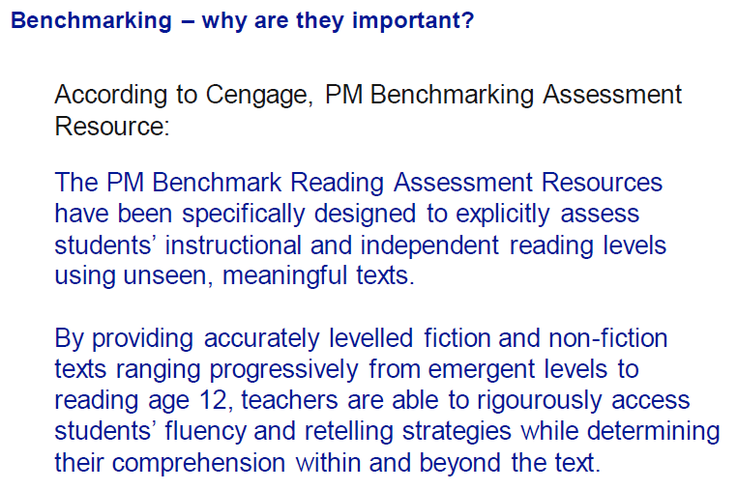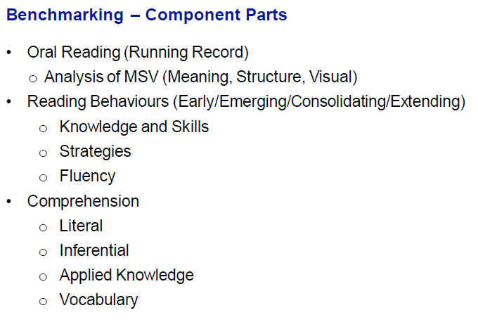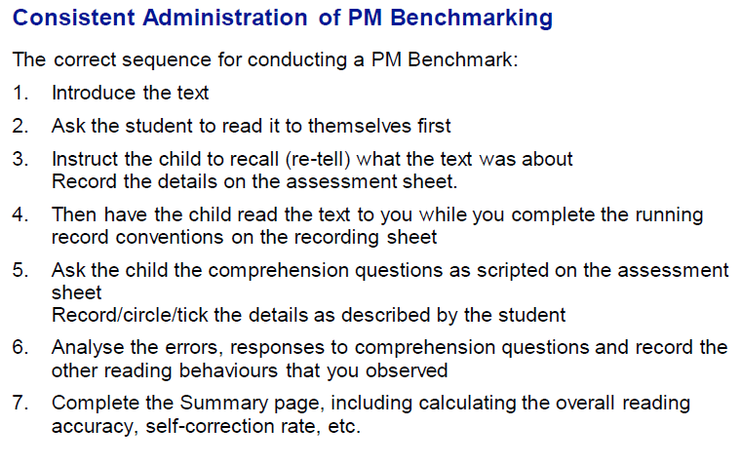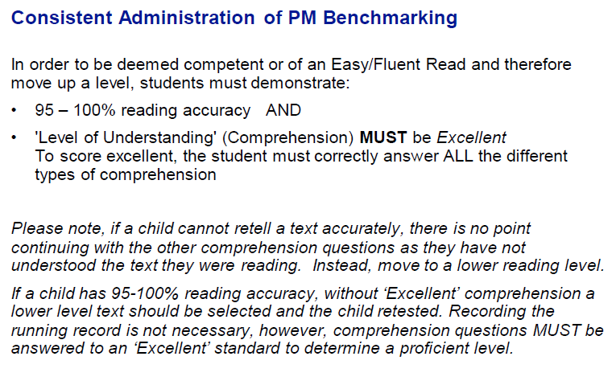

Appendix 2
Protocols for the Administration of On Demand Adaptive Test
On Demand Testing: Information
- On Demand Testing is an online resource for teachers to use when, where and how they choose. Tests are designed to link to curriculum and standards. It is a time-saving tool that can be administered to a single student and/or a whole class.
- The On Demand testing program is a valuable tool for schools, enabling them to conduct assessment in a reliable and standardised manner.
- To assist teachers with a variety of assessment needs, On Demand tests can be used for:
  - pre-testing students prior to beginning a topic
  - applying the same test to post-test a topic of work
  - testing new intake students or a late arrival
  - identifying individual student's strengths and weaknesses
  - corroborating teacher judgments
  - assisting in forward planning of teaching programs.
- Depending on the type of test administered, teachers have the option to display scores to students and view results through a range of available reports. The system has the capacity to store results from a range of assessment tasks, enabling teachers to track and monitor student progress over time.
- The assessments are composed of items in the following formats:
  - multiple choice
  - type in short answer
  - hot spot
  - drag and drop
  - mathematical calculator
  - open text response.

- Computer Adaptive Tests deliver sets of questions to students that vary according to student ability. Depending on the responses given in previous questions, the system presents progressively easier or more difficult questions to the student.
- There are currently three reports available for Computer Adaptive Tests - the ‘Class Standard Score Report’, the ‘Student Test Session Performance Report’, and the ‘Student Tracking Report’. These reports provide immediate feedback on the results for each student, including an estimated ability score. Question level analysis is also possible for Computer Adaptive Tests through the ‘Student Test Session Performance Report’.

ADMINISTRATION

Years undertaking the tests | Years 3 to 9
Students undertaking the tests | ALL students  Students on ILP’s negotiated based on goals listed in ILP
Timing of the Tests | Round 1 – June  Round 2 - November
Tests number undertaken  Reading Comprehension (Adaptive Test) | Year 3 - #4068  Year 4 - #4069  Year 5 - #4070  Year 6 - #4071  Year 7 - #4072  Year 8 - #4073  Year 9 - #4074
Results recorded | Markbook – Data Triangulation Columns Semester 1 and 2

Appendix 3
Protocols for the Administration of the PAT-R

PAT-R Information

- PAT Reading 5th Edition is an assessment of students’ ability to understand what they read. The tests include a wide range of texts to reflect the variety of students’ reading experiences and to assess the knowledge and skills that students develop in their journey towards becoming proficient readers. Text types include informational, narrative, persuasive and procedural. The assessment consists of nine test forms that increase in difficulty from Test P to Test 10.

- PAT Reading 5th Edition has been developed exclusively for online administration, allowing the use of new interactive item types and features. In addition to simple multiple choice items, the new edition includes some drag-and-drop and complex multiple choice items, in which students are required to enter multiple responses. A new hyperlink feature has also been added to a selection of items, allowing students to highlight relevant words within a reading text.

- Choosing the right test is necessary to ensure that students’ results provide useful information about their current ability in the learning domain.
- The difficulty of a test form and the teacher’s knowledge of a student should be taken into consideration in selecting an appropriate test form. Curriculum appropriateness and the context of the classroom also need to be taken into account when making this decision.

- When a student can answer around 50% of the questions correctly, the test is well targeted and provides considerable information about the skills a student is demonstrating, and those she or he is still developing. While it is the case that very high or very low PAT scores will have larger error margins, measurement error should not be the motivating factor in test selection.

- There is often a wide range of ability within the classroom and reading skills exist on a continuum, so it is not necessary to provide all students in a class with the same test. Instead the focus should always be each student’s ability at the time of the assessment, not where they are expected to be.

- To make decisions about which test is most appropriate for a particular student or group of students, it is essential that the teacher previews and becomes familiar with the content of the tests.

ADMINISTRATION

Years undertaking the tests | Years 1 to 9
Students undertaking the tests | ALL students  Students on ILP’s negotiated based on goals listed in ILP
Timing of the Tests | Week 1-2 Term 1  Week 1-2 Term 3
Tests undertaken  Number of Questions on the test | - Test P contains 23 questions – Year Prep or 1  - Test 1 contains 18 questions – Year Prep or 1 or 2  - Test 2 contains 25 questions – Year 1 or 2 or 3  - Test 3 contains 28 questions – Year 2 or 3 or 4  - Test 4 contains 30 questions – Year 3 or 4 or 5  - Test 5 contains 34 questions – Year 4 or 5 or 6  - Test 6 contains 35 questions – Year 5 or 6 or 7  - Test 7 contains 35 questions – Year 6 or 7 or 8  - Test 8 contains 34 questions – Year 7 or 8 or 9  - Test 9 contains 37 questions – Year 8 or 9 or 10  - Test 10 contains 36 questions – Year 9 or 10  `
Results recorded | Markbook – Data Triangulation Columns Semester 1 and 2

APPENDIX 4
Protocols for the Administration of Running Records
A Running Record provides information on the following:
- a score of word reading accuracy
- an analysis of a reader's errors and self-corrections
- an analysis of the reading strategies used.
- fluency and comprehension.
Using a series of established conventions, a teacher can quickly and accurately record what the reader says as they read a text or section of a text aloud. After the reading, the teacher completes an analysis.
Conventions
There is a set of universal conventions (developed by Clay, 1993) which allow teachers to accurately record what a child articulates as they read a text or section of a text.
Using the agreed conventions ensures colleagues and other professionals also can understand and interpret the running record. This promotes consistency of approach because all stakeholders (e.g. classroom teachers, members of a professional learning team, literacy coordinators, leadership teams, allied health professionals and/or parents) can accurately see and understand a record of a student's reading at a given point in time. See following pages for further explanation of the conventions.

Levels of text difficulty
According to the number of errors and self-corrections, a mathematical formula is used to determine the level of text difficulty. For example:
Readers who score 95-100% word accuracy
Are decoding texts which are easy and do not provide any challenges for problem solving strategies. These texts are useful for promoting phrasing, fluency and vocabulary recognition.
Readers who score 90-94% word accuracy
Are decoding instructional texts which have the 'right' amount of challenge for developing and practising new reading strategies. This level of text difficulty will be just 'right' if the teacher provides guidance and feedback to ensure students can practise the new skills and support.
Readers who score below 90% word accuracy
Are decoding text that is too hard, will most likely in a loss of meaning or engagement with the text. These texts are best to read to students.

In addition to the Running Record and its analysis, two other important aspects must be assessed to give a teacher a full insight into what a student does when they read. These are:
A comment on how the reading sounded
  - is the reading phrased and fluent?
  - was expression used?
  - was the reading word by word?
  - were there pauses at appropriate punctuation?
Straight after the reading, the teacher makes notes on how the reading sounded. Making a comment on fluency is important as there are no Running Record symbols to represent this.
Determining comprehension levels
Can the student:
retell the text in sequential order?
answer literal questions? (Right there on the page)
answer inferential questions? (Use background knowledge and text clues or search the text)
answer evaluative questions? (‘Big picture’ concepts that the text has addressed).

All of this information can then be used to develop targeted learning intentions which will inform future teaching and student learning. A Running Record has a relevance span of about three weeks.
For an accurate picture of a student’s reading, Running Records should be taken on a passage of text with 100-150 words or the entire text if less than that.

RUNNING RECORD CONVENTIONS
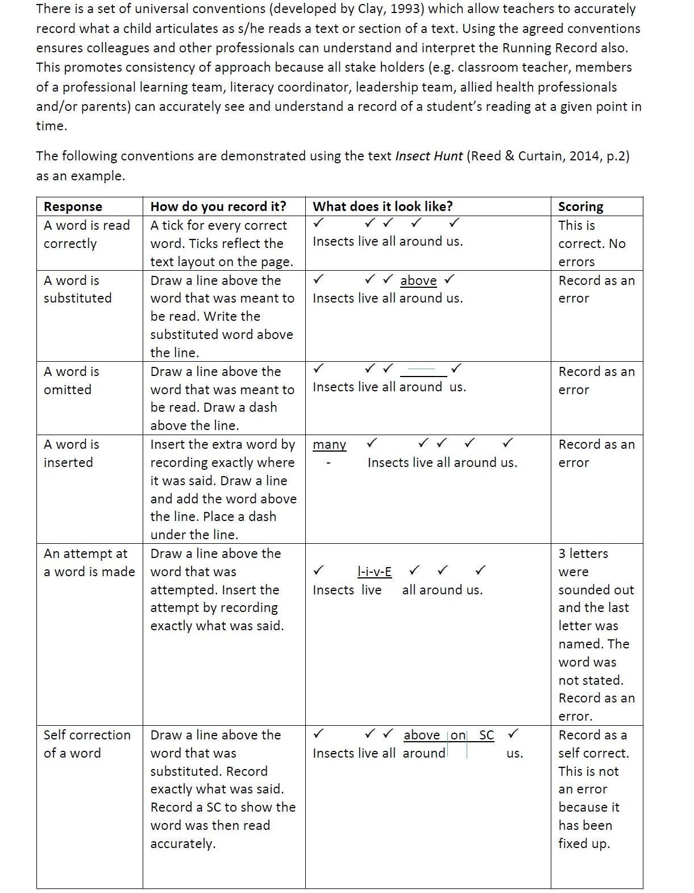
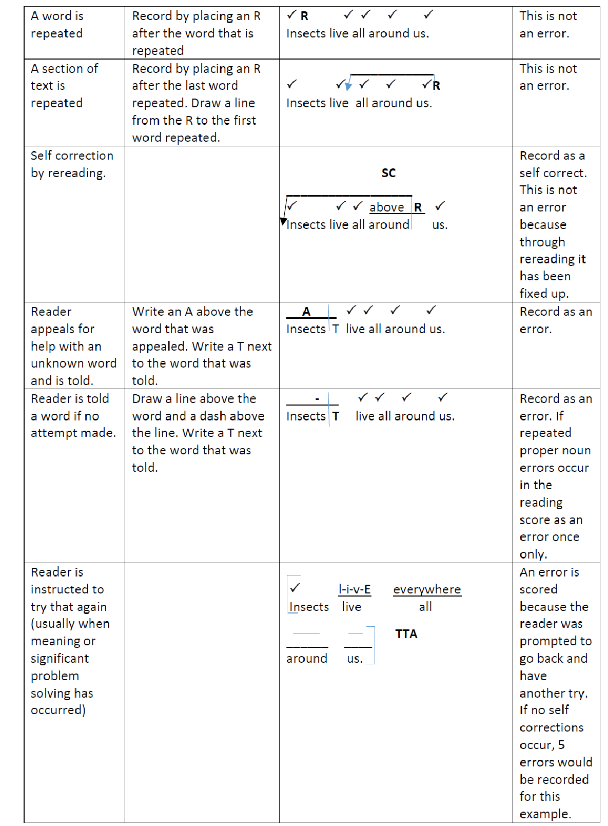
APPENDIX 5: The Lakes South Morang Reading and Viewing Non Negotiables P-6

APPENDIX 6: Samples of Student Reading Surveys for use Foundation to 9

APPENDIX 7: Samples of Reading Logs for use Foundation to 9

APPENDIX 8: Independent Reading Engagement Inventory Foundation to 6

APPENDIX 9: Assessing Fluency Years 7-9

APPENDIX 10: Year level CATS

APPENDIX 5: The Lakes South Morang Reading and Viewing Non-Negotiables P-6
APPENDIX 6: Samples of Student Reading Surveys for use Foundation to 9
APPENDIX 7: Samples of Reading Logs for use Foundation to 9
APPENDIX 8: Independent Reading Engagement Inventory Foundation to 6
APPENDIX 9: Assessing Fluency Years 7-9
APPENDIX 10: Year Level Common Assessment Tasks for the Assessment of Reading

The Lakes, South Morang

Reading and Viewing non-negotiables

Years P - 6

Preamble

If we, the teachers and staff at The Lakes…………then the reading

To be an effective reader requires skills and understandings in decoding, text use and text analysis. Each of these skills and understandings is crucial in its own right, but they all take place within an overall focus on meaning making, which is the central purpose of all literate behaviour. Meaning making must be central to the teaching of reading. All teachers are expected to teach phonics explicitly, alongside supporting students’ literal, inferential and evaluative comprehension and to support students’ interest, engagement and enjoyment with books and other texts that they read and view. (DET, 2017)

Non-Negotiables for All Reading and Viewing lessons

At The Lakes, South Morang we will…
- Teach five (5) hours of explicit reading lessons per week
- Follow The Lakes, South Morang assessment schedule
- Plan consistently across the primary years and
  - explicitly document and clearly display/refer to a learning intention and success criteria for every lesson
  - plan for, document and follow the agreed structure for the teaching reading as outlined below
  - document and plan for fluid and flexible groupings within the class based on data
  - assessment of students used to inform guided reading groups and activities
- Incorporate the High Impact Teaching Strategies into reading lessons
- Commit to assessment for learning

Structure of a Reading Lesson
Each hour session will comprise of the following structure:

WHOLE CLASS 15 min.  Approximately 1min for each year of students age | Getting Knowledge Ready | - Review current knowledge and connect to prior learning connect to prior learning  - Discuss vocabulary (explicit meaning)  - Word fluency
 | Lesson Learning Intention and Success Criteria | - Discuss Learning Intention (LI) and Success Criteria (SC) clearly written/referred to using student friendly language  - SC must link directly to LI not student behaviour
 | Mini Lesson including – Modelled or Shared Reading | - Explicitly teach reading strategy/s  - Read to and with the students vocalising and demonstrating reading strategy/s  - Ask questions about reading strategy and comprehension (don’t forget higher order questions)  - NB: Every child should be reading the same text. This can either be a big book, displayed on IWB, photocopy of text, book/s etc.
 | Launch | - Explain instructions for the small group / individual part of the lesson  - Display group activities which are linked to Learning Intention
 | Catch (2mins) | - Check in with LI and SC  - Check in with students to check they understand task / strategy and re-explain/demonstrate as required
SMALL GROUP / INDIVIDUAL  35 min.  Guided to Independent Practice | Worktime / Explore Part One  (15mins)  - Develop student understanding of the concept or skill through activities and exercises  - Guided reading focus group/s  - Applications of skills and/or concepts in different contexts  - Must be related to Learning Intention  - Differentiation of tasks using prior assessment | Guided Reading  - Explicitly teach reading strategy with guided reading group (may have a different learning intention to whole class focus)  - Monitoring and assessment of students - ongoing, running records, checklists, anecdotal, observations  - Specific teaching of reading strategies, comprehension  - Assess student’s current knowledge and note new learning goals  - Provide feeback to students  Students independent activities:  - Familiar Reading  - Individual reading for a purpose  - Reciprocal Reading  - Literacy Circles  - Critical questioning  - Text matched to ability with some challenge  - Differentiated, multi entry groups  - Rich and varied learning tasks  - Variety of text genres  - Application of skills and concepts in different ways  - Make connections to other learning contexts  - Practise new learning  - Self-assessment
 | Catch (3mins) | - Check in with LI and SC  - Check in with students to check they understand task / strategy and re-explain/demonstrate as required
 | Worktime / Explore Part Two  (15mins) | - As per part one
WHOLE CLASS  10 min.  Review / Debrief | Reflect | - Refer to Success Criteria  - Ask open ended higher order questions  - Checklist on any individual presentations  - Discuss students though processes (metacognition)  - Exit passes  - Quick formative assessment  - Share work  - Provide feedback

Student Reading Survey / Interview Questions
Lower Primary

My name: | Date:
My Class:

Sample Questions

Draw a picture of yourself reading in your favourite place

Do you like to read? Why? Why not?
What are some of the books you have read lately?
Who is your favourite author?
What topics do you like to read about?
Do you read at home?
Who reads to you at home?
Do you like enjoy having someone read to you? Why? /Why not?
What does the word ‘reading mean to you?
What do you do well as a reader?
What would you like to get better at this year as a reader?
Student Reading Survey
Upper Primary

Name: | Date:
Class:

Sample Questions
Do you like to read? Why? Why not?
Where do you like to read?
What do you like to read?
Do you read at home?
What do you read at home?
Do you like reading on a device? Why/ Why not?
Do you have a favorite author or favourite authors? If so, who are they?
What do you think wise readers do?
What do you do well as a reader?
What would you like to work on as a reader?

Year __ Readers

Ten Questions About Reading
Upper Primary and into Years 7- 9

- What texts do you like to read? (Tick as many as you like):
- Novels
- Graphic novels/comic books
- Short stories
- Poems
- Songs
- Blogs
- Newspaper articles
- Magazine articles
- Plays
- Picture books
- Other (please indicate):_____________________

- What are your favourite genres? (Tick as many as you like):
- Action
- Adventure
- Biographies
- Mystery
- Dystopian (set in a horrific future, like ‘Hunger Games’)
- Romance
- Drama
- Comedy
- Fantasy
- Science Fiction
- Travel
- Sport-related
- Non-fiction
- Crime
- Animated
- Western
- Historical
- Historical fiction
- Horror
- Mystery
- Other (please list)____________________________

- On a scale of 1 (least enjoyable) to 5 (most enjoyable), how much do you enjoy reading?
- Explain your answer to Question 3 –why do you/don’t you enjoy reading?

- What do you enjoy most about reading?

- What do you like least about reading?

- On a scale of 1 (not confident at all) to 5 (extremely confident), how confident do you feel that you are a strong reader?

- Explain your answer to Question 7. Why do you feel that you are/aren’t a strong reader?

- What are some of your biggest successes as a reader? How did you achieve these?

- What is the hardest part of reading for you? Explain.

Book Logs for younger readers who read books multiple times.
This simple tally log records the number of times a book has been read from start to finish. For this log, a child needs to know how to keep a tally mark. I often teach students to keep the log on their desks as they read and to record a tally mark on the log as soon as they finish one book.
An alternative is to place a sticky not on the back cover of each book in the student’s book box or baggie and teach the students to tally on the sticky note as soon as they finish reading the book.
Taken from The Literacy Teacher’s Playbook Grades K-2, Serravallo, J. (p.5)

Name: |  | Week of:
Book Titles | Tally Marks

Taken from The Literacy Teacher’s Playbook Grades K-2, Serravallo, J. (p.6)
Book Logs
Students use book logs to record text titles, the time they spend on reading and the number of pages read. Depending on the age and reading ability of the students, you can have the child record start and end times and start and end pages, or you can simply tell the child the number of minutes they have been reading.

My Daily Reading Log
(Put a tick next to the title when you finish a book)
Date | Title | Start Time | End Time

My Daily Reading Log
(Put a tick next to the title when you finish a book)
Date | Home  /School | Title | Author | Start Page | End Page | Minutes Read | Level (optional)
 | H/S
 | H/S
 | H/S
 | H/S
 | H/S
 | H/S
 | H/S
 | H/S
 | H/S
 | H/S
 | H/S
 | H/S
 | H/S

Book Log
Name:

No. | Title | Author | Date started | Date finished | Genre | E, JR or C

Book Log
Name:

No. | Title | Author | Date started | Date finished | Date  aband. | E, JR or C | Genre

Independent Reading Engagement Inventory
Year:
Teacher:
Directions: Use this tool to tally students’ behaviours during independent reading. Data collection should occur two to three reading sessions to identify students having difficulty engaging.

Student | Out of seat | Continually looks up/around the room | Flips pages/ not reading | Talks | Switches books | Total no. of off-task behaviours observed | Notes

Assessing Fluency Years 7-9
When listening to a student reading aloud, you will want to assess the degree to which they can process a text with fluency. Assessing a student’s fluency is not as straight forward as it may seem because there is a chicken and egg relationship between fluency and comprehension. To read fluently, a reader needs to understand what they are reading. However, to understand the text, a reader needs to be able to read it fluently. (Serravallo, 2013)
Reading rate or speed is just one aspect of fluency. Serravallo (2013) refers to Kuhn’s (2008) description of fluency as encompassing accuracy, automaticity, phrasing and prosody, each of which is described in more detail below.
Accuracy refers to the reader’s ability to identify words correctly.
Automaticity relates to the reader’s ability to recognize words right away, without having to apply any strategies to figure them out. A reader can have a perfect accuracy rare, but not be very automatic. This would sound belabored and choppy.
Phrasing refers to the reader’s ability to accurately break up, or phrase, longer sentences into syntactically appropriate phrase units. Often, this means a reader need to have some felt sense of how English syntax works, with phrases and clauses as part of longer sentences. It may also mean the at the reader is able to pay attention to medial punctuation like commas, semicolons, and dashes. If a reader is able to pay attention to correct phrases, comprehension could be altered.
Prosody relates to a reader’s ability to apply the appropriate amount of stress, emphasis, and intonation so that the reading sounds like how we talk. Without strong prosody, reading can sound monotone and dronelike.
Fountas and Pinnell (2006) present six dimensions of fluency to be considered when assessing a student’s fluency.
- Pausing (using punctuation)
- Phrasing (reflecting meaningful units of language)
- Stress (placing emphasis appropriately on words
- Intonation (varying the tone, pitch, and volume to reflect the meaning)
- Rate (using an appropriate pace-not too slow or too fast)
- Integration (consistently and evenly orchestrating pausing, phrasing, stress, intonation and rate)

Because reading fluency is multidimensional, it is important to teach and monitor.
The ability to measure students’ level of achievement in fluency and monitor their progress is key to successful fluency teaching. Teachers need to be able to gauge the effectiveness of their instruction in fluency; to do this, they need ways to assess student fluency.
First, fluency assessments must have some degree of reliability and validity. Users of the assessments must be assured that the results they obtain are reliable – that the results will provide consistent measures of fluency and will not vary because of imperfections in the assessment itself. Users must also be assured that the assessments are valid – that they actually measure reading fluency. The assessments themselves should resemble the ways in which reading fluency is defined.
Fluency assessments need to quick and easy to use. If not, teachers may not find the time to use them of may use them in ways that are inconsistent with their intent.

Strategies for Assessing Fluency
Using the Six Dimensions Fluency Rubric - Fountas and Pinnell
Preparation
To use this scale, find a readable text, one a student can read with over 95% accuracy. A student’s fluency cannot be assessed if they are reading a text that is not accessible.
Decide if your will use a first or second reading of the text. In general, fluency is best assessed on a second read.
Procedure
  - Provide a brief short, standardised introduction to the text.
  - Ask the student to read a significant portion of the text aloud; or have the student read the text once in full and then read it aloud for the second time.
  - Follow along as the student reads, using your own copy of the text, and marking errors.
  - Check the reading for accuracy – noting whether it is above 95%.
  - Use the scale with the definitions to rate the reading along the first five dimensions. Remember you are rating this reading, rather than the reader. Any individual student might read fluently on one text and dysfluency on another. You are taking a snapshot at one pace in time on one text.
  - Then make an overall assessment of the student’s fluency using “integration’, which refers to the way the reader has used all of the dimensions. If you can avoid it, don’t simply average your ratings. Think about the reading holistically. To what extend does the reading sound like fluent, phrased, expressive reading to your ear?
Teaching for Comprehending and Fluency Thinking Talking, and Writing About Reading, K-8 Fountas and Pinnell (2006)

Rubric on following page.

SIX DIMENSIONS FLUENCY RUBRIC
1. Pausing: Pausing refers to the way the reader’s voice is guided by punctuation (for example, short breath at a comma; full stop with voice going down at periods and up at question marks; full stop at dashes).
0 | 1 | 2 | 3
Almost no pausing to reflect  punctuation or meaning of the text  Needs intensive teaching and/or  text not appropriate | Some pausing to reflect the punctuation and meaning of  the text  Needs explicit teaching,  prompting and reinforcing | Most of the reading evidences appropriate pausing to reflect the punctuation and meaning of the text.  Needs some prompting and  reinforcing | Almost all the reading is characterised by pausing to reflect punctuation and meaning of the text.  Teaching not needed

2. Phrasing: Phrasing refers to the way readers put words together in groups to represent the meaningful units of language. Sometimes phrases are cued by punctuation such as commas, but often they are not. Phrased reading sounds like oral language, though more formal.
0 | 1 | 2 | 3
No evidence of appropriate  phrasing during the reading  Needs intensive teaching and/or  text not appropriate | Some evidence of appropriate  phrasing during the reading  Needs explicit teaching,  prompting and reinforcing | Much of the reading evidences  appropriate phrasing.  Needs some prompting and  reinforcing | Almost all the reading is  appropriately phrased.  Teaching not needed

3. Stress: Stress refers to the emphasis readers place on particular words (louder tone) to reflect the meaning as speakers would do in oral language.
0 | 1 | 2 | 3
Almost no stress on appropriate  words to reflect the meaning of  the text  Needs intensive teaching and/or  text not appropriate | Some stress on appropriate  words to reflect the meaning of  the text  Needs explicit teaching,  prompting and reinforcing | Most of the reading evidences  stress on appropriate words to  reflect the meaning of the text.  Needs some prompting and  reinforcing | Almost all of the reading is  characterised by stress on  appropriate words to reflect the  meaning of the text.  Teaching not needed

4. Intonation: Intonation refers to the way the reader varies the voice in tone, pitch and volume to reflect the meaning of the text—sometimes called expression.
0 | 1 | 2 | 3
Almost no variation in voice or tone (pitch) to reflect the meaning of the text  Needs intensive teaching and/or  text not appropriate | Some evidence of variation in  voice or tone (pitch) to reflect  the meaning of the text  Needs explicit teaching,  prompting and reinforcing | Most of the reading evidences  variation in voice or tone (pitch)  to reflect the meaning of the  text.  Needs some prompting and  reinforcing | Almost all of the reading  evidences variation in voice  or tone (pitch) to reflect the  meaning of the text.  Teaching not needed

5. Rate: Rate refers to the pace at which a reader moves through the text—not too fast and not too slow. The reader moves along steadily with few slow-downs, stops or pauses to solve words. If the reader has only a few short pauses for word solving and picks up the pace again, look at the overall rate.
0 | 1 | 2 | 3
Almost no evidence of  appropriate rate during the  reading  Needs intensive teaching and/or  text not appropriate | Some evidence of appropriate  rate during the reading  Needs explicit teaching,  prompting and reinforcing | Most of the reading evidences  appropriate rate.  Needs some prompting and  reinforcing | Almost all of the reading  evidences appropriate rate.  Teaching not needed

6. Integration: Integration involves the way a reader consistently and evenly orchestrates rate, phrasing, pausing, intonation and stress.
0 | 1 | 2 | 3
Almost none of the reading is  fluent.  Needs intensive teaching and/or  text not appropriate | Some of the reading is fluent.  Needs explicit teaching, prompting and reinforcing | Most of the reading is fluent.  Needs some prompting and reinforcing | Almost all of the reading is  fluent.  Teaching not needed

Guiding Principles for Rating Try to focus on one aspect at a time but give your overall impression.
0 | 1 | 2 | 3
Needs intensive teaching and/or  text not appropriate | Needs explicit teaching,  prompting and reinforcing | Needs some prompting and  reinforcing | Teaching not needed

Fountas & Pinnell Benchmark Assessment Systems 1 & 2
© 2010 by Irene C Fountas and Gay Su Pinnell. Portsmouth, NH: Heinemann & Pearson Australia. This page may be photocopied.

Using a Fluency Record
Instead of listing for miscues while a child reads aloud, listen with an ear toward the student’s fluency to take a fluency record. Make a slash each time you hear a student pause. Record information about the student’s intonation or expression. This can be done on its own or part of a running record.
If part of a running record, you might ask a student to read 100 words as you listen for miscues, then listen for the second 100 words as you record information about fluency. (Serravallo 2014)
Serravallo (p8)
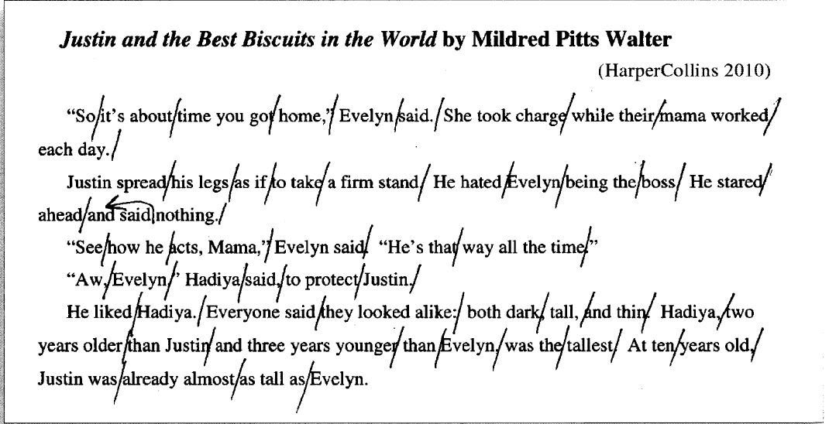

Observable Behaviours of Fluent and Non-Fluent Readers

Non-Fluent Reader | Fluent Reader
Observable behaviours: | Observable behaviours:
- Fails to read punctuation with variance and voice | - Reflects punctuation with variance in the voice-pausing intonation, pitch and stress
- Pauses randomly, not reflecting logical phrase units | - Pauses appropriately to reflect meaningful phrase units (although not always) in response to punctuation
- Reads in a choppy or word by word way | - Groups words into phrases that reflect meaning
- Uses few rising and falling tones or monotonously applies rising and falling tomes to produce ‘droning’ | - Uses rising and falling tomes in a way that reflect meaning and punctuation (is not monotonous)
- Stresses few words or places, inappropriate stress on words | - Places stress on words in a way that reflect meaning
- Uses little or no expression, sometimes uses inappropriate expression | - Uses expression to reflect their interpretation of the meaning of the text
- Reads slowly | - Reads with good momentum, although not so fast that phrasing is lost
- Fails to vary speed or varies it in an inconsistent and unpredictable way | - Varies speed, slowing down and speeding up for various purposes
- Fails to differentiate dialogue from other forms of text | - Reads dialogue in a way that reflects aspects of characters, their ways of expressing themselves, and oral language
- Reads slowly or stops in an attempt to pick up and remember all the details | - Focuses on meaning; doesn’t get bogged down in details
- Reads in a way that doesn’t reflect awareness of language syntax | - Reads in way that reflects awareness of language syntax, with error behaviour indicating such awareness

Teaching for Comprehending and Fluency Thinking Talking, and Writing About Reading, K-8 Fountas and Pinnell (2006)

